

Process of Orders for Materials - Packing


Through SAP Business Network

Dear Ariba User,

To support you in the development of activities within the SAP Ariba Network system, this guide presents the description of the general transaction process for material procurement cases.
Please read the information in this manual carefully to learn about the sub-processes that you must complete in SAP Ariba in order to manage your purchase order for materials.

Content
1. Purchase Order Receipt 3
2. Goods Receipts 6
3. Invoice Registration 7
Fill in invoice information 8
4. Validate Invoice Rejection 12
5. Validate Invoice Status 14
Invoice Information 16
Invoice details 16
6. Scheduled Payments 18
Historical 18
Remittances received 19

Purchase Order Receipt
When you receive a purchase order from your customer to be processed in Ariba, you receive an email indicating your referral to the SAP Business Network portal.
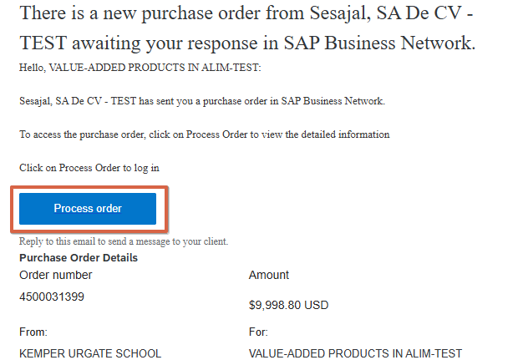
- Select the "Process Order" button to access the system.

- Once you are redirected to the system, you must log in with your account credentials.

Note: If you have already registered, it is also possible to access the order directly from the Ariba Network portal (Business Network Login) using the following options:

Option No.1 Enter the Work Panel, then you must access the "orders" tab and then "Purchase orders"
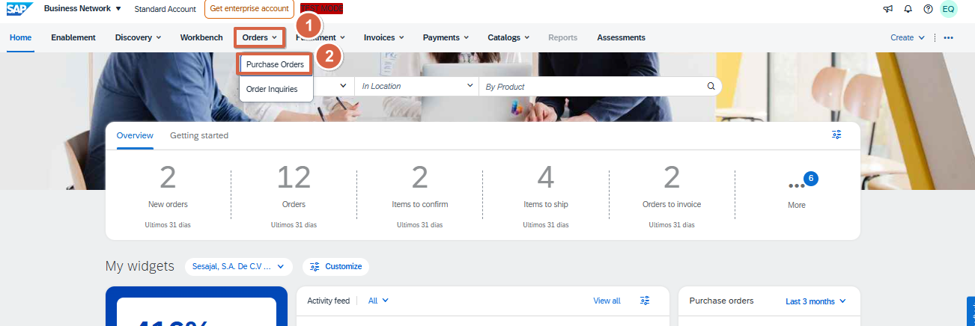
Option No.2 Enter the Work Panel, then you will have to click on "orders"
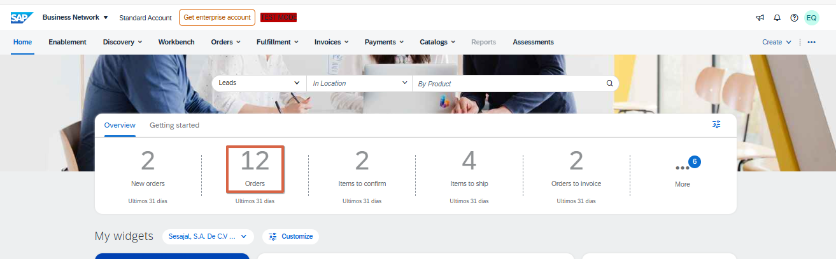

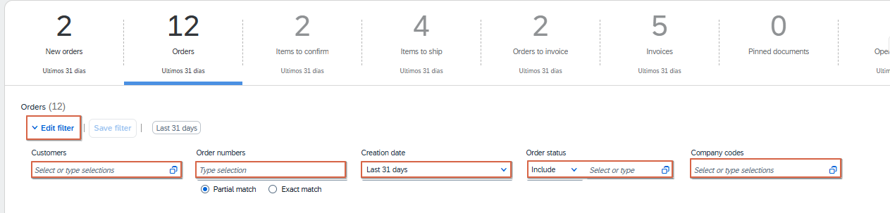
- Depending on the way in which the Work Panel is configured, several ordering options will be accessible. Despite this, it is recommended to always access "Option 1" as all orders received are displayed here, regardless of their status.

- Click on "Edit filter" and then select the filter you want to apply. If you have the order number, you can select "Exact match" and type it.

Important: Place the "Last 365 days" option in the "Date created" filter, so that all orders received in the last year can be displayed.

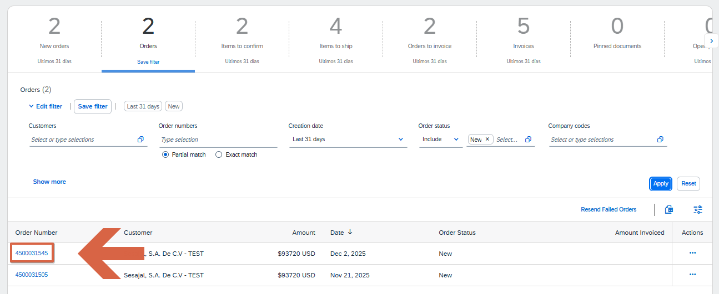
- The supplier always gets the order from the Ariba Network supplier portal. To be able to enter you must click on the order number.
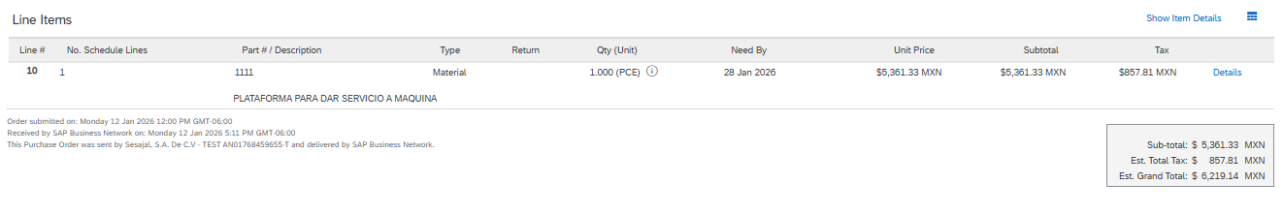
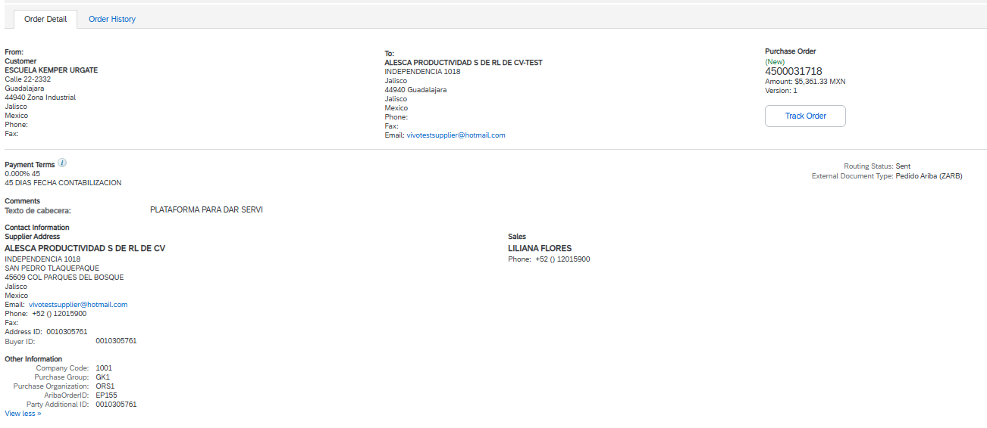

Goods Receipts

Once one or more deliveries have been made to your order, its status will change to "Received" or “Partially Confirmed”.
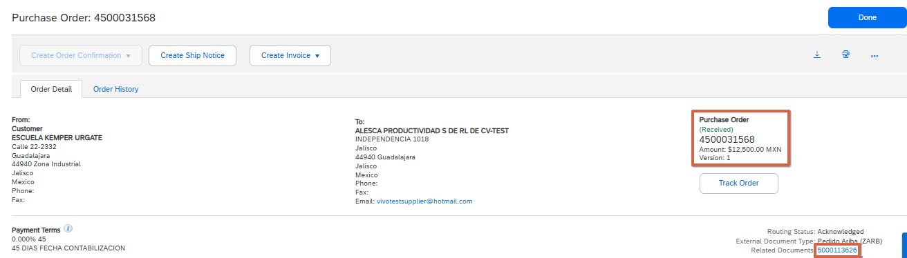
Important Note: Please note that creating the invoice requires the customer to send a document called "Goods Receipts." This document is also sent via Ariba and can be viewed in the related documents section of the purchase order.

Note: The user must have the "Invoice Generation" permission assigned. Additionally, if anything is pending, it is recommended to contact the buyer so they can assist in generating or approving the corresponding document.

Invoice Registration
- Log in to your SAP Business Network account, by accessing from the following link: Ariba Network for suppliers

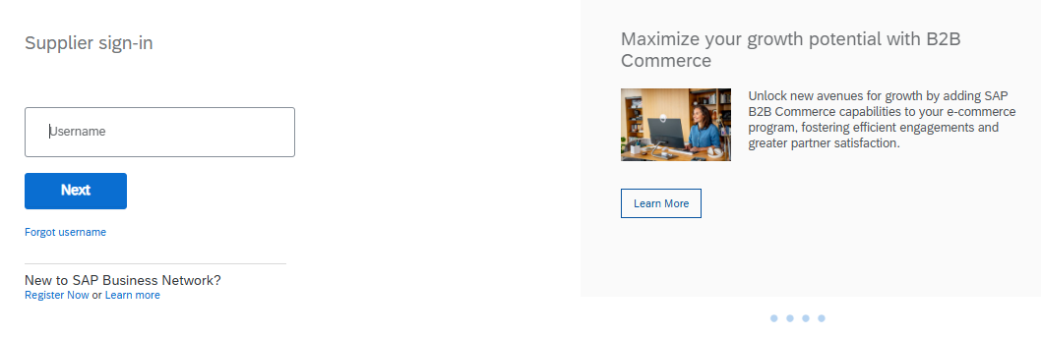

Note: in case you do not remember your username or password, you can click on "Forgot username or password" and it will redirect you to another page where you can reset your username or password, as appropriate.

- Search for and enter the purchase order to be invoiced.

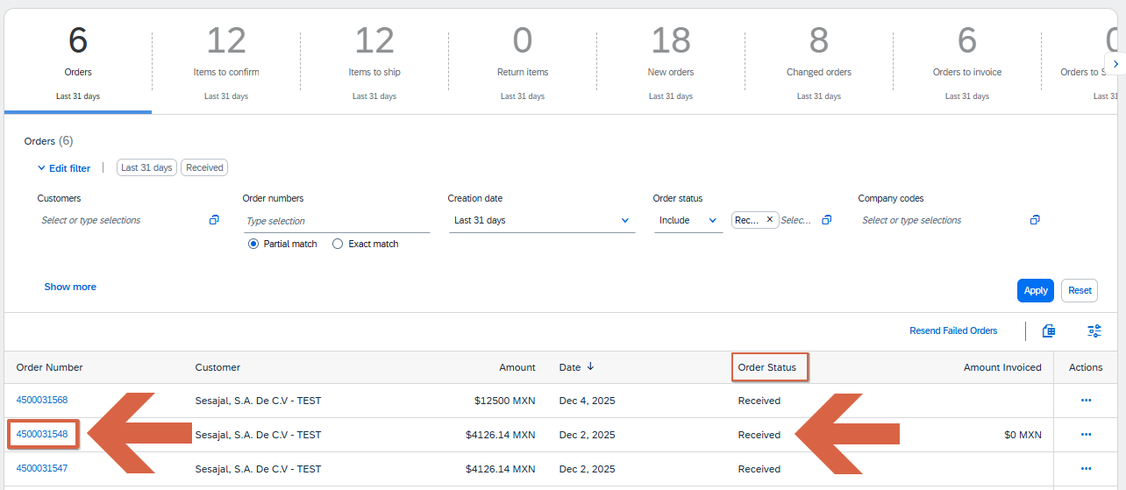
Note: Only orders marked as ‘received’ or ´Partially Received´ status can be invoiced within the platform. If the order has already been shipped, you may notify the buyer to request a status change.

- Click on the "Create invoice" button and then select the "Standard invoice" option.
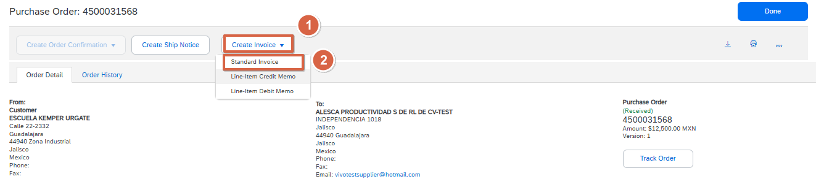

Fill in invoice information

- Complete all the requested information, taking into account that the mandatory fields are marked with an asterisk ( * ).

Invoice header:

  - Invoice No: You must enter the invoice number.

- Date of the invoice: date stamped in the invoice
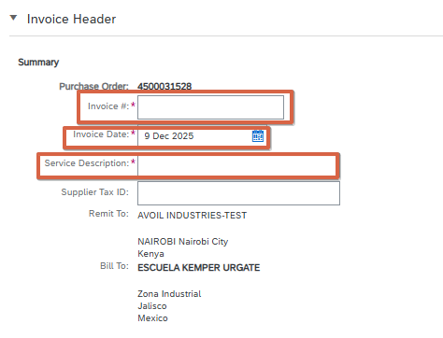
- Description: You must fill in this field with the overview of what you are billing.

- SUPPLIER AND BUYER TAX IDENTIFICATION NUMBER (RFC): TAX IDENTIFICATION NUMBER OR CODE

Important: If you are a foreign supplier, you must enter your Tax ID number and it is mandatory that you place it in the field "Supplier NIF/CIF" or "Supplier VAT/Tax ID".

Attachments:

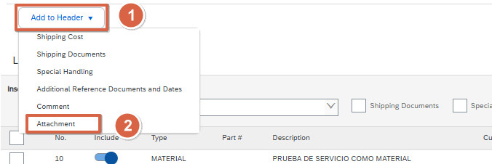
- Click on the "Add to header" button and then select the "Attached" option

- Click on "Select file", select the file you want to upload and then click on

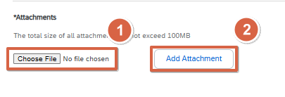
"Add Attachment"

Invoice attachments:
- Files: It is mandatory to attach both the PDF and XML files of the supplier invoice for vendors within Mexico. (Suppliers outside of Mexico must attach only the PDF.)
Invoice lines:

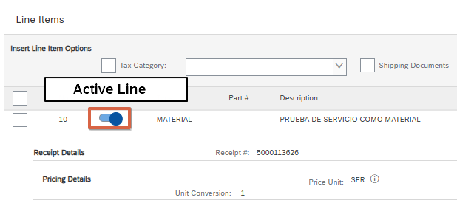
Select the lines you want to include and check that the quantity is correct.
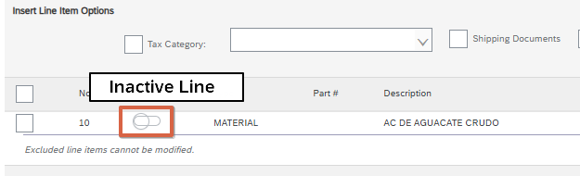
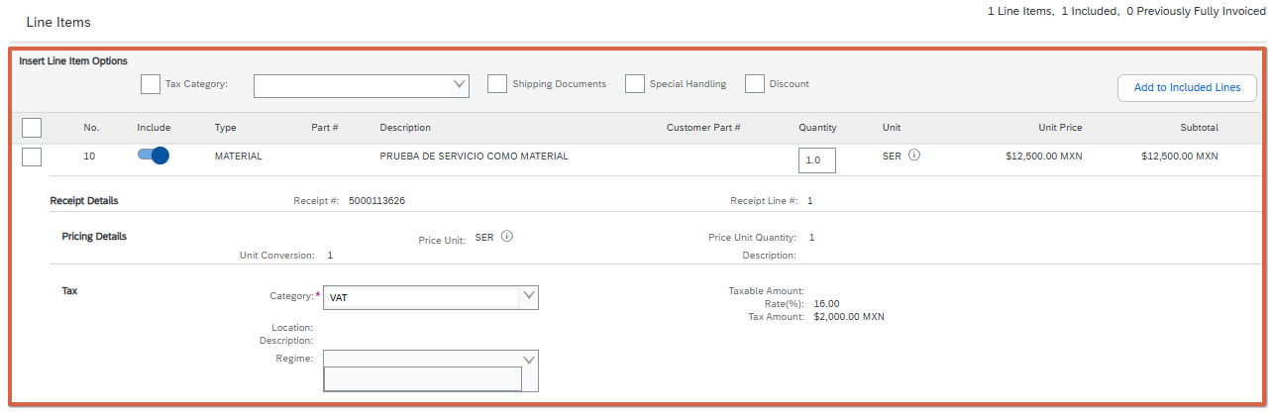

- Check that all the requested information has been completed and then click on "Next"
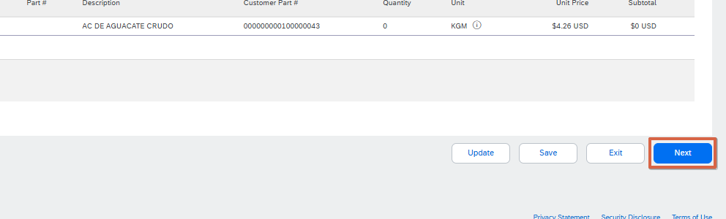

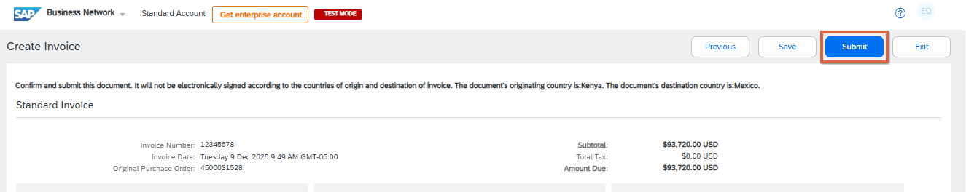
- Validate that all the information is correct and click on "Submit".

- Validate that the invoice was sent successfully. To do this, you must check that the status of the purchase order has changed to "Invoiced" or "Partially invoiced", depending on the case.
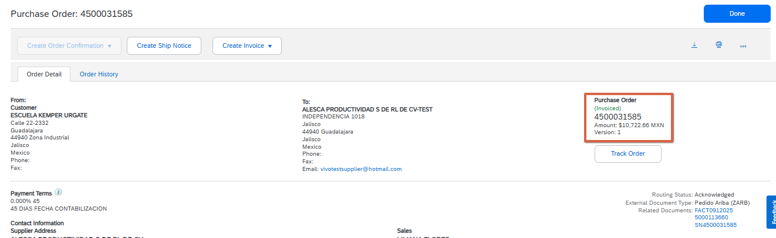

4. Validate Invoice Rejection
To check if the invoice was rejected, the following must be done:
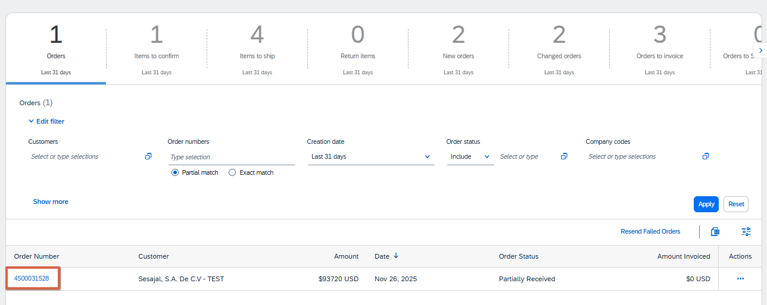
- Find and enter the purchase order where the invoice was sent.

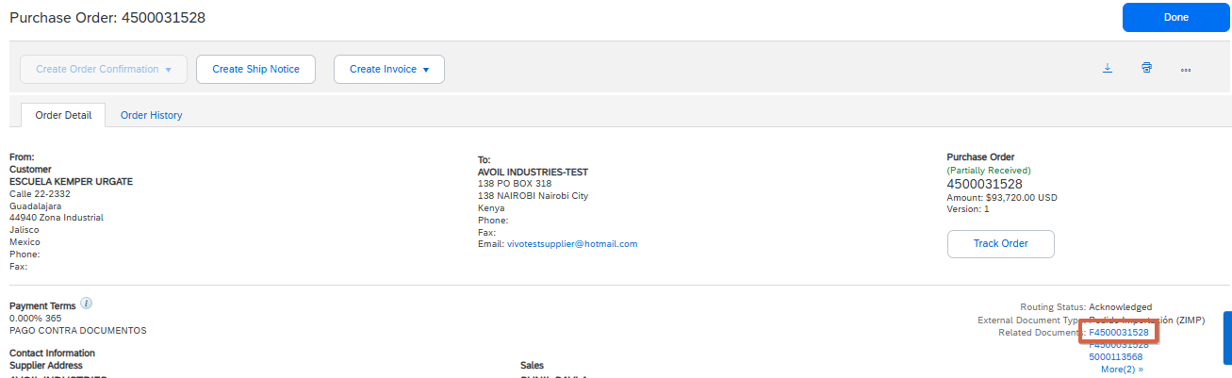
- Within the purchase order, you must look for the related documents section and enter the invoice sent.

- In case the invoice has been rejected, a light blue box will appear in the details tab indicating the reason for rejection. This can also be validated from the history tab.

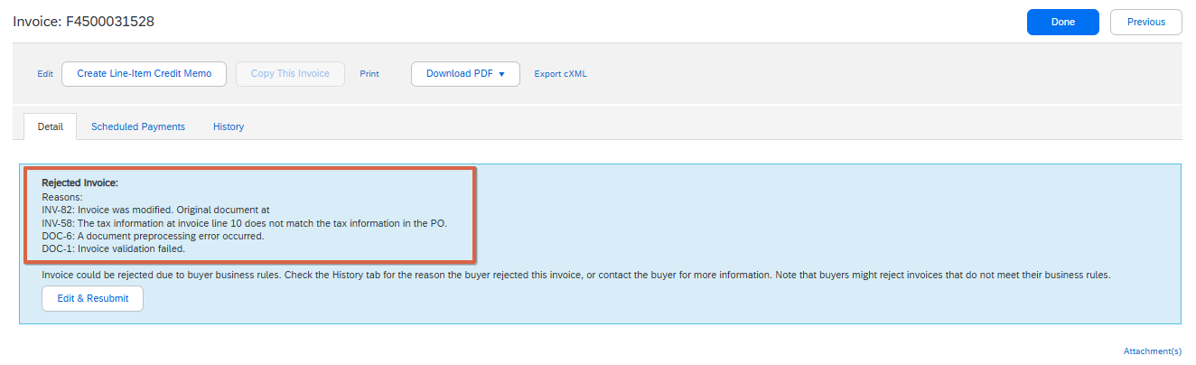

- After reviewing the reason for rejection, click on "Edit and resubmit". This with the aim of
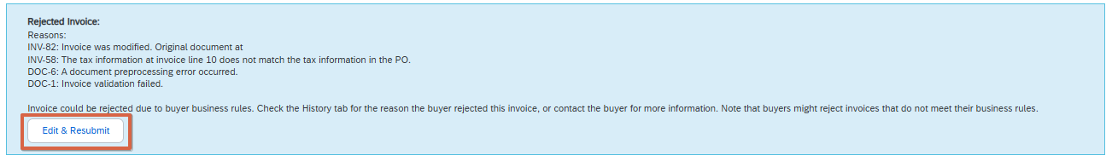
that the invoice should not be created from scratch.

- Make required modifications.
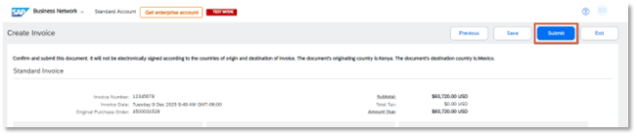
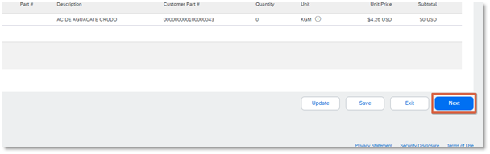
- Click on "Next" and then on "Submit".

5. Validate Invoice Status
Once you have sent an invoice, you can view the status it is in.
Note: Log in to your SAP Business Network account, by accessing from the following link: Ariba Network for Suppliers
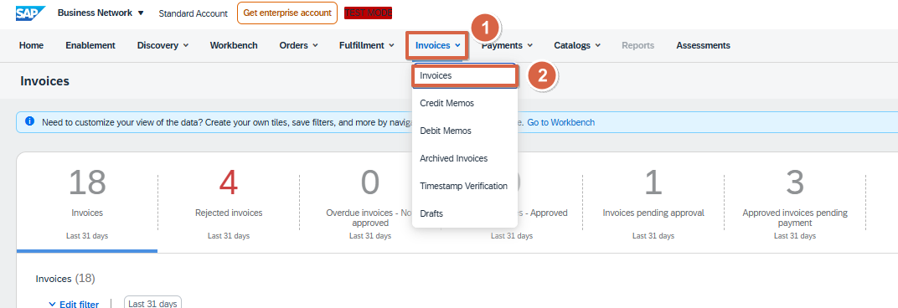
- Search and select the invoice to be validated.

- Once inside the invoices we can locate the one we are looking for in two ways.
  - Invoice number
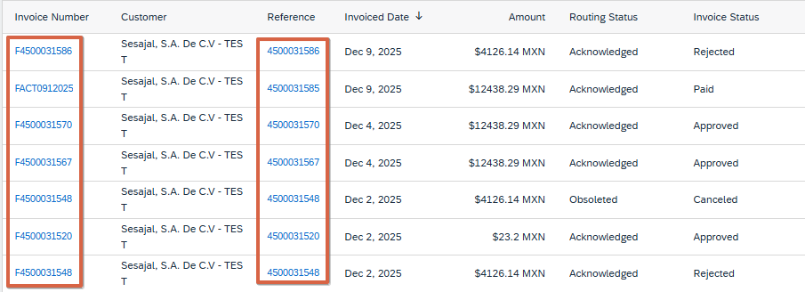
  - Purchase Order Number (Reference)

- After locating our invoice we can validate what state it is in, for this we have 5 possible options:
- Sent: The invoice has been delivered to the buyer.
- Approved: The bill was reviewed and approved (Not yet paid).
- Rejected: The invoice was reviewed and rejected (Can be edited and resubmitted).
- Cancelled: The invoice was reviewed and cancelled (This invoice is no longer valid, a new one needs to be made).
- Paid: The invoice was reviewed and paid.

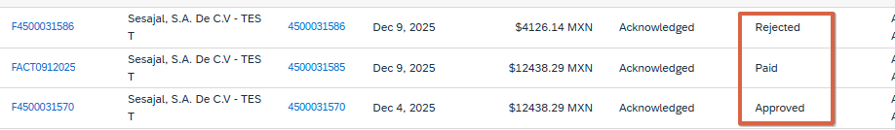

Invoice Information

- Once the invoice is located, you can access to view its information by clicking on the invoice number, where you can view the invoice number, the drop-down bar that includes:
  - Details: All the information regarding the invoice.
  - Scheduled Payments: If you have payments for upcoming dates, you can view them here.
  - History: you can view the process through which the invoice has passed.

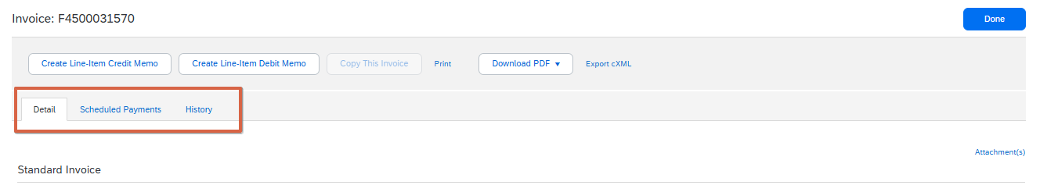

Invoice details

- Selecting the "Details" option is usually the default view. Here you will be able to see all the information of the invoice such as: status, payment total, payment method, see the image below.
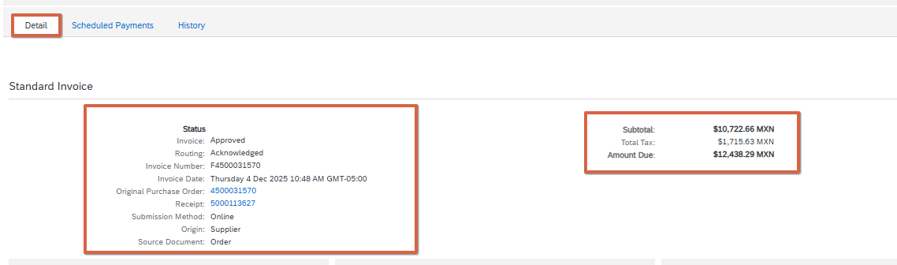

- In addition to the above, you will also be able to view the information of shipment, detail of the invoice, detail of taxes and Attachments. See images below.

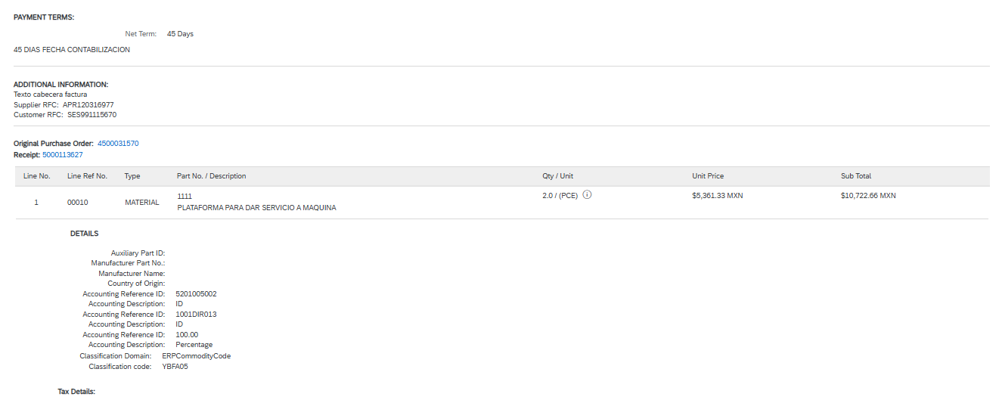

6. Scheduled Payments

- Select the "scheduled payments" option
If you have any payment scheduled on this invoice, you could see them in this tab

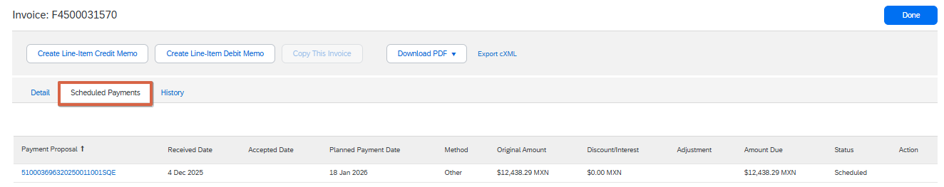

Note: If the status of your payment schedule is marked as 'on hold,' you must contact your buyer to inquire about the reason for the hold.

Historical
- Select the "Historical" option
Here you can see the process through which the invoice has passed. You can display the columns of:
  - State: The state in which it is located
  - Comments: If someone added a comment
  - Modified by: The person who made the modification
  - Date and Time: The date and time the change or update was made

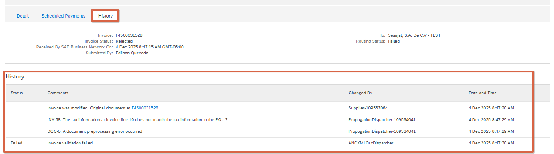

Payment Notification
- To view your payments made, go to the top of the home screen, select Payments, and then Remittances.
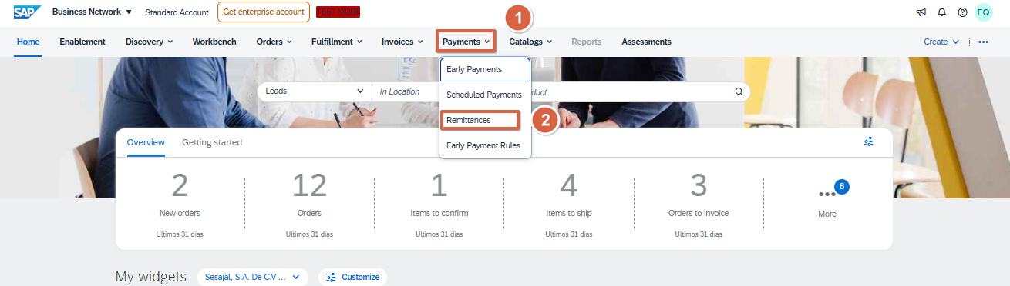

Remittances received
- On the payments page, you can view the payments received according to the filter you have applied and the total monetary amount received in the filtered period.
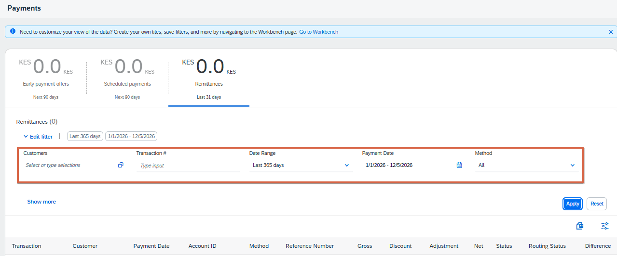

- After applying the filters, you will be able to view the remittances that correspond to that filter, locate the payment associated with the reference number that is the purchase order number to which the payment was made, and click on the transaction number to see the details.
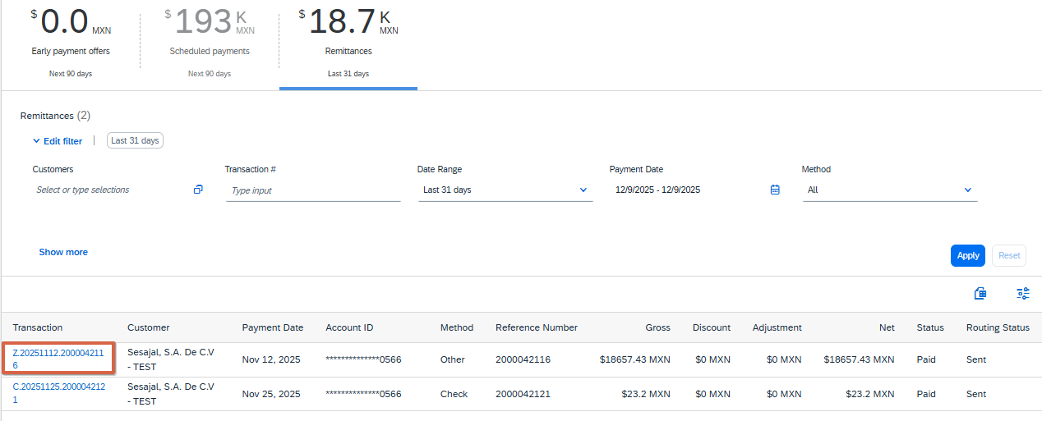

- Within the remittance you will be able to view the related data:
  - Remittance Notice Identification Number
  - Payment status
  - Gross Amount
  - Withholdings or discounts applied
  - Total amount paid
  - Payment settlement date
  - Payment Method
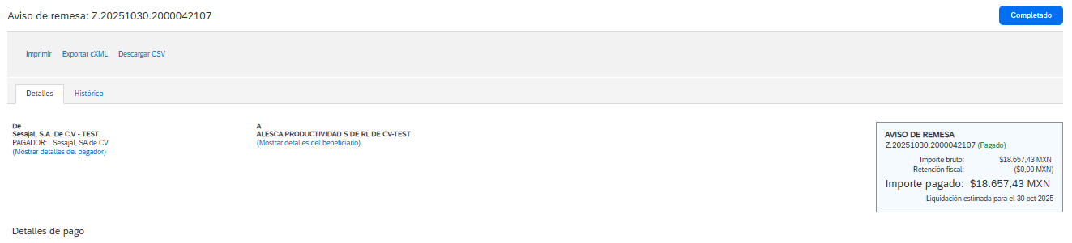
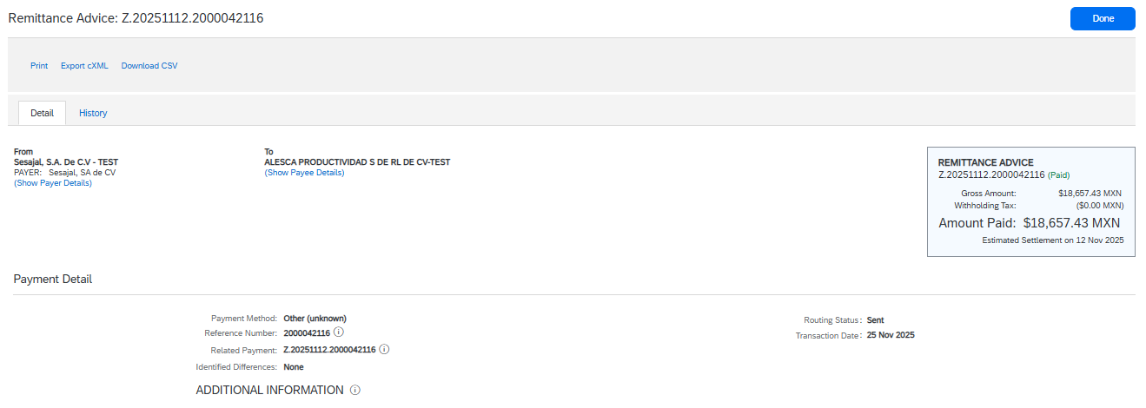
- In addition to the above, you can also view the invoices paid in this transaction, since a purchase order can have several invoices.

