

General Process of Managing Orders for Materials


Through SAP Business Network

Dear Ariba User,

In order to support you in carrying out activities within the SAP Ariba Network system, this guide provides a description of the general transaction process for the goods and services (OBS) scenario.
Please read the information in this manual carefully to learn about the sub-processes that you must complete in SAP Ariba in order to manage your purchase order.

Content
Purchase Order Receipt 3
Notice of Shipment 6
Initial considerations ¡Error! Marcador no definido.
Create Shipment Notice 6
Completing Shipment Notice Information 7
Goods Receipts 10
Requirements to create an invoice 11
Invoice Registration 12
Fill in invoice information 13
Validate Invoice Rejection 17
Validate Invoice Status 19
Invoice Information 21
Invoice details 21
Scheduled Payments 23
Historical 23
Remittances received 24

Purchase Order Receipt
When you receive a purchase order from your customer to be processed in Ariba, you receive an email indicating your referral to the SAP Business Network portal.
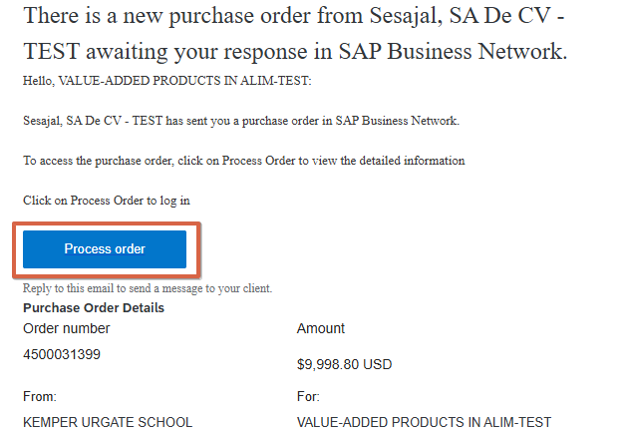
- Select the "Process Order" button to access the system.

- Once you are redirected to the system, you must log in with your account credentials.

Note: If you have already registered, it is also possible to access the order directly from the Ariba Network portal (Business Network Login) using the following options:

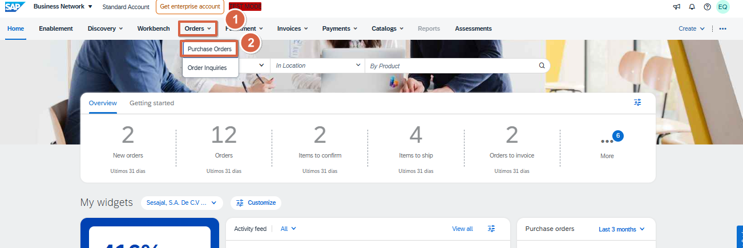
Option No.1 Enter the Work Panel, then you must access the "orders" tab and then "Purchase orders"

Option No.2 Enter the Work Panel, then you will have to click on "orders"
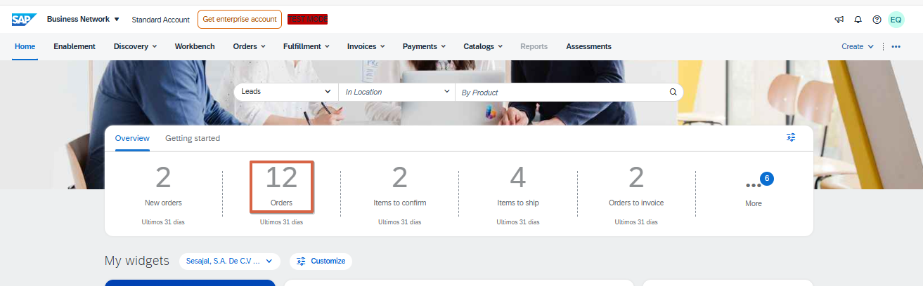

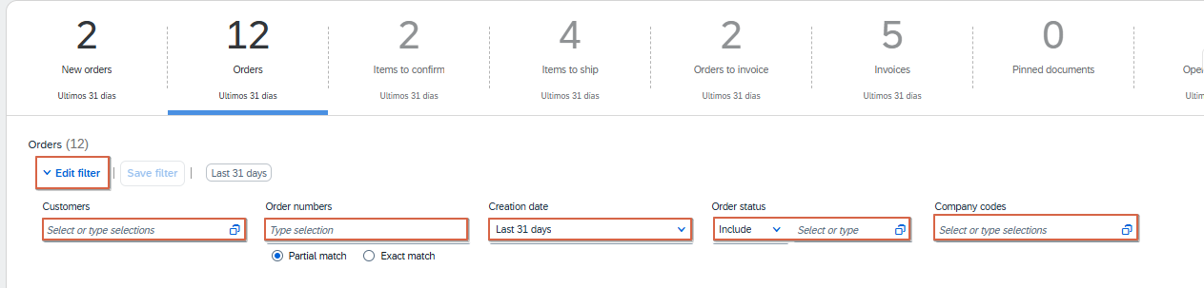
- Depending on the way in which the Work Panel is configured, several ordering options will be accessible. Despite this, it is recommended to always access "Option 1" as all orders received are displayed here, regardless of their status.

- Click on "Edit filter" and then select the filter you want to apply. If you have the order number, you can select "Exact match" and type it.

Important: Place the "Last 365 days" option in the "Date created" filter, so that all orders received in the last year can be displayed.

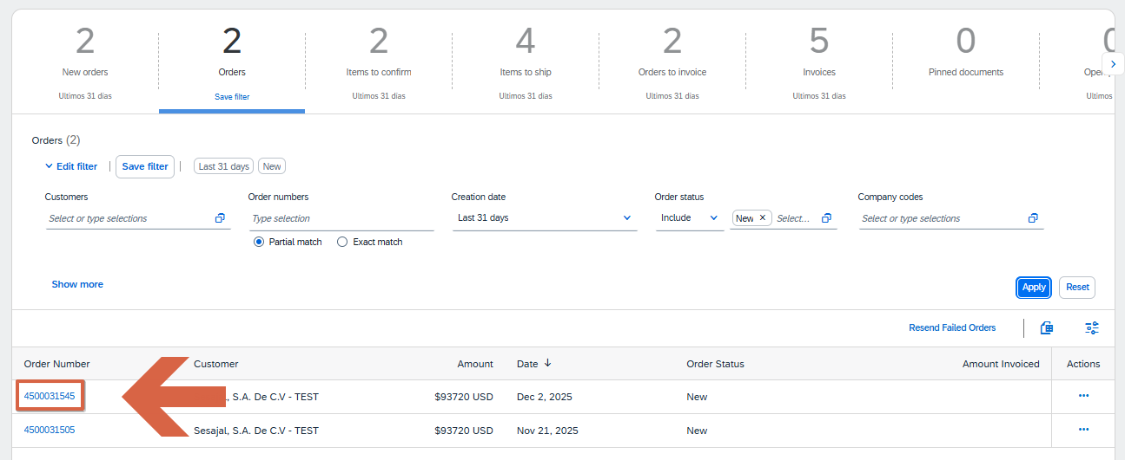
- The supplier always gets the order from the Ariba Network supplier portal. To be able to enter you must click on the order number.

- Once inside the order detail, you must validate that the order data is correct.
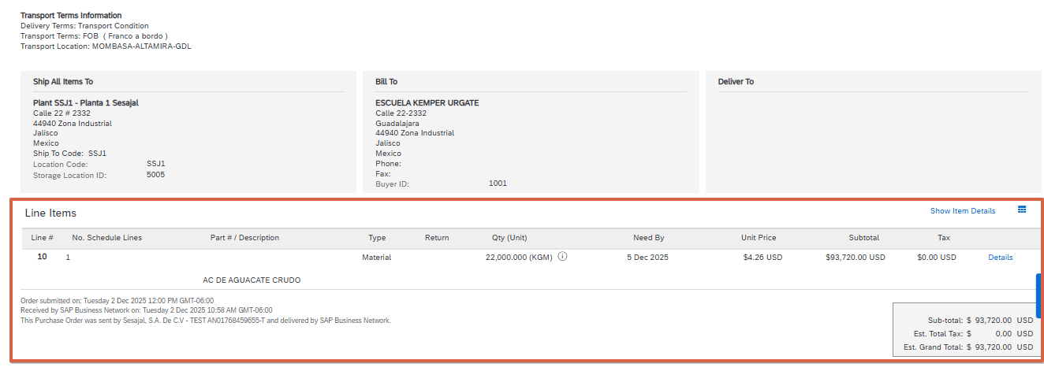

Note: in case any information of the order is not correct (amounts, quantity, Unit.) it is recommended to contact the buyer first and request the modification.

Notice of Shipment

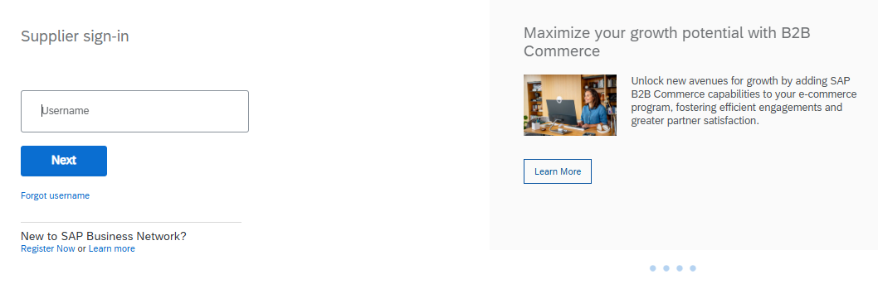
- Log in to your SAP Business Network account, by accessing from the following link: Ariba Network for suppliers.

Create Shipment Notice
- On the Ariba homepage, enter the corresponding order, going to the
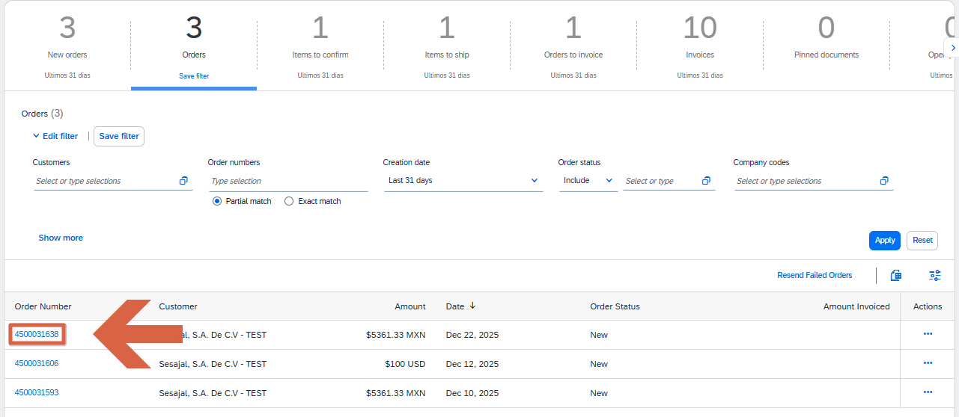
"Orders"

- then click on the "Create shipment notice" button.
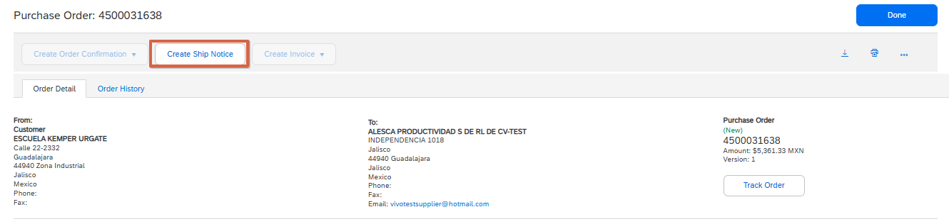

Completing Shipment Notice Information
- Complete all the requested information, taking into account that the only mandatory fields are the following:
IMPORTANT: You must complete all fields marked with an (*) as they are mandatory.

Header of the dispatch notice:

  - Packing List ID: Refers to the number on the waybill. The platform allows a maximum of 16 characters.
  - Delivery date: date on which the items ordered in the order will be delivered.
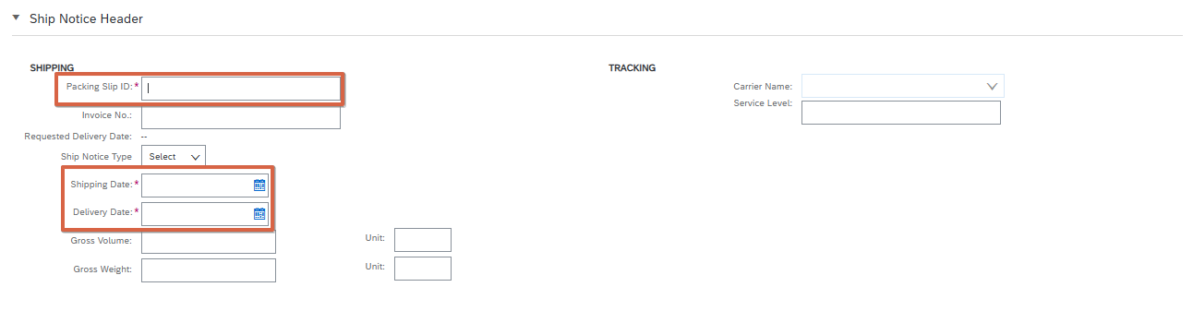
If you need to attach documents, you can do so by clicking on choose file and then add attachment.
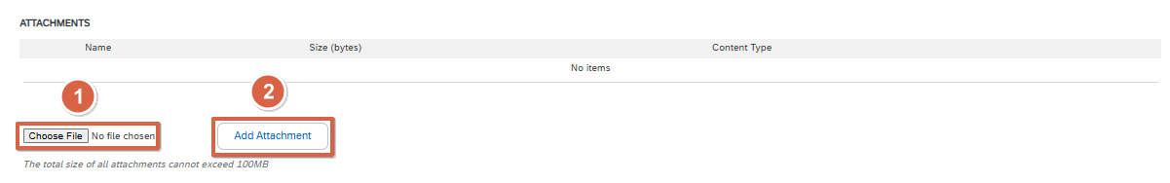

Order Items:

- Enter the exact quantity that will be delivered in the field "Ship QTY" since the system automatically assigns the total order quantity. You can edit the quantity in case you want to make a partial shipment.

Note: In case any of the items are not going to be delivered at that time, you must
delete this line by clicking on the "Remove" option that appears on the right side.
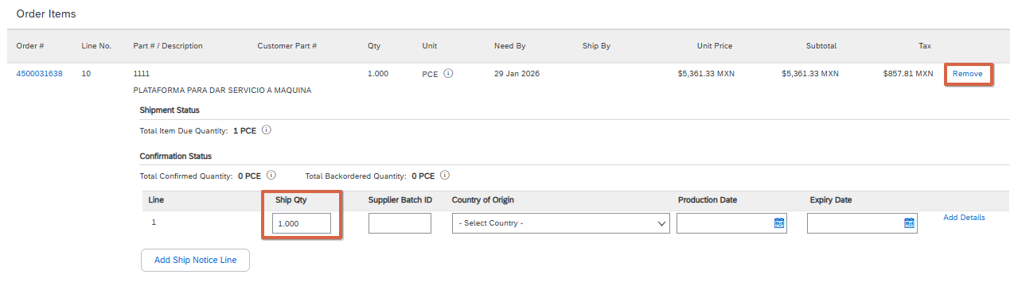

- Once the information is completed, select "Next"
- Validate that all the information is correct and click on "Submit".

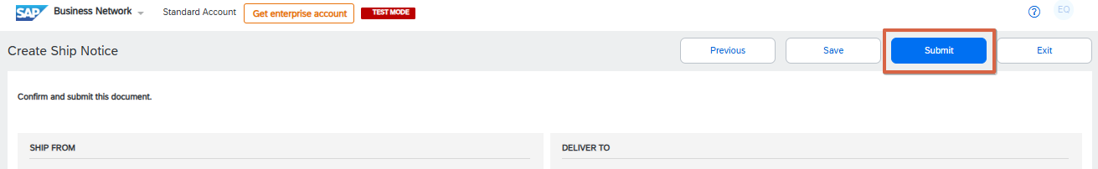
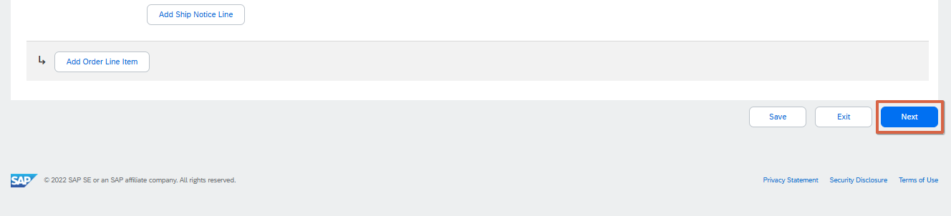

Note: in case you are not sure that the information entered is correct, it is recommended to click on "Save" and enter the document to send it until you have the complete information.

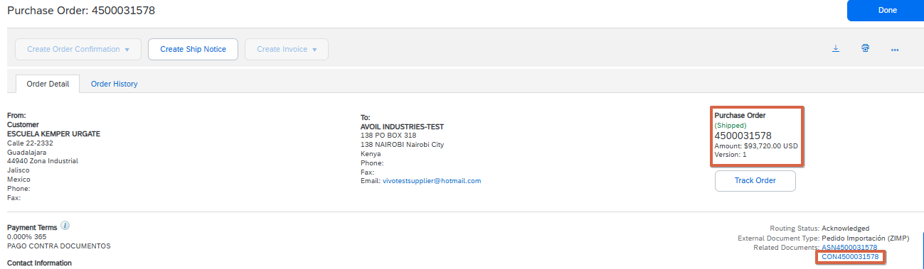
- Validate that the shipment notice has been sent correctly. To do this, you must check that the status of the purchase order has changed to "Shipped" or "Partially shipped", depending on the case. Additionally, in the related documents section you will be able to view the shipment notice sent

Goods Receipts

The shipment notice must be sent for each delivery of material made.
Important Note: Please note that sending a dispatch notice does not automatically enable the option to create the invoice since the customer is required to send a document called "Goods Receipts". This document also travels through Ariba and can be viewed in the related documents section of the purchase order.
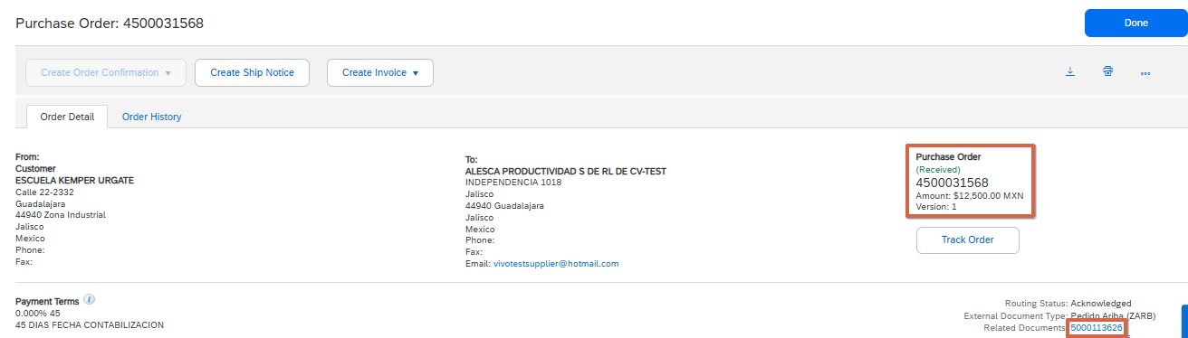

Requirements to create an invoice
For the Create Invoice button to be enabled, the following requirements must be met:

- The order must be in a received or partially received status and include the following:

  - Order of materials: have received an Goods Receipt in Ariba. This document is sent by the customer and can be viewed within the related documents of the order.
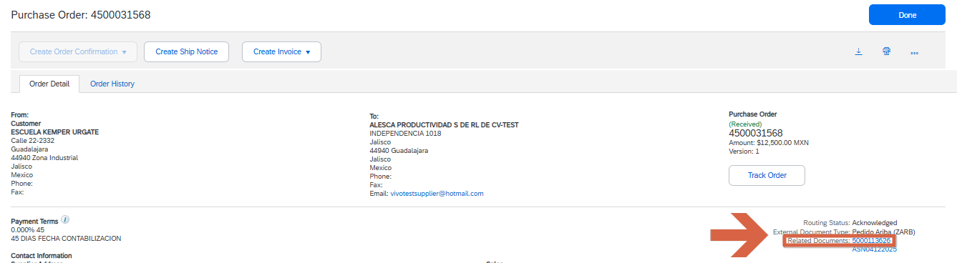

- User must be assigned the "Invoice Generation" permission

Note: in case something is pending, it is recommended to contact the buyer so that they can help generate or approve the corresponding document.

Invoice Registration
- Log in to your SAP Business Network account, by accessing from the following link: Ariba Network for suppliers

Note: in case you do not remember your username or password, you can click on "Forgot username or password" and it will redirect you to another page where you can reset your username or password, as appropriate.

- Search for and enter the purchase order to be invoiced.

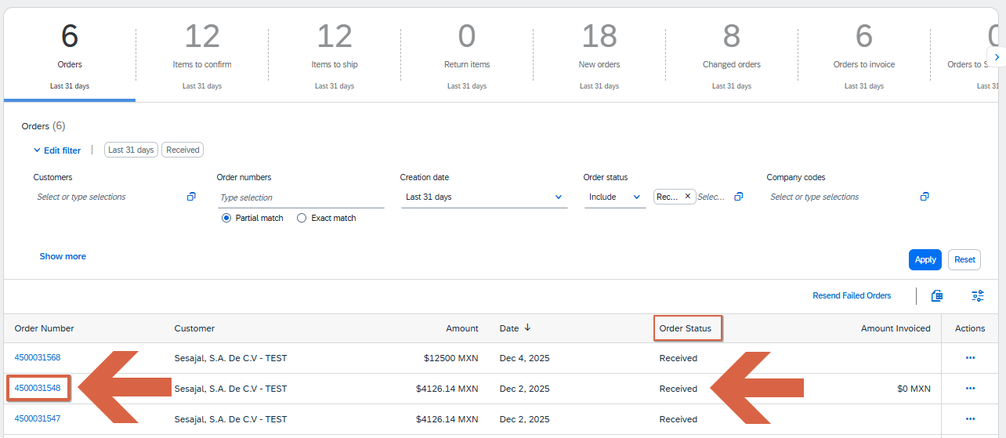
Note: Only orders in a received or partially received status can be invoiced within the platform. If the order has already been received by the buyer, you may notify them to update the status.

- Click on the "Create invoice" button and then select the "Standard invoice" option.
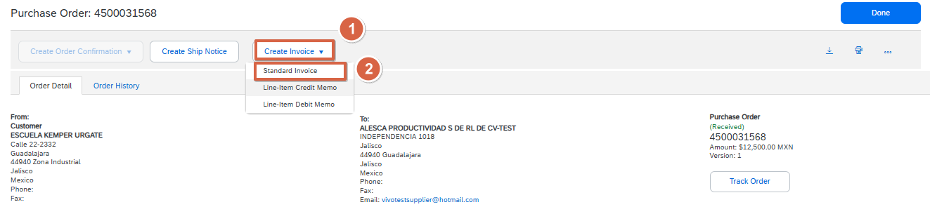

Fill in invoice information

- Complete all the requested information, taking into account that the mandatory fields are marked with an asterisk ( * ).

Invoice header:

  - Invoice No: You must enter the invoice number.

- Date of the invoice: date stamped in the invoice
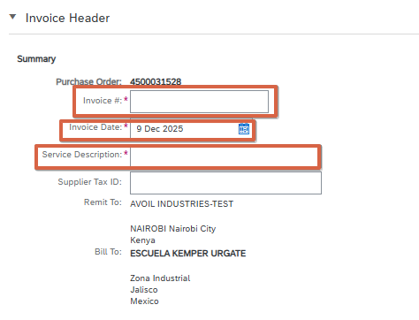
- Description: You must fill in this field with the overview of what you are billing.

- SUPPLIER AND BUYER TAX IDENTIFICATION NUMBER (RFC): TAX IDENTIFICATION NUMBER OR CODE

Important: If you are a foreign supplier, you must enter your Tax ID number and it is mandatory that you place it in the field "Supplier NIF/CIF" or "Supplier VAT/Tax ID".

Attachments:

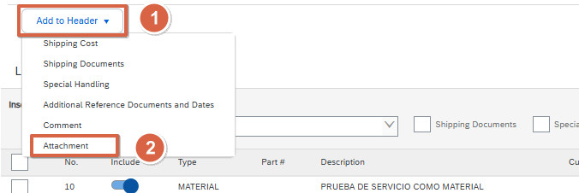
- Click on the "Add to header" button and then select the "Attached" option

- Click on "Select file", select the file you want to upload and then click on

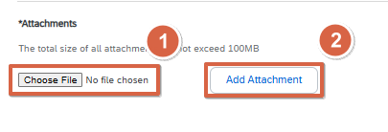
"Add Attachment"

Invoice attachments:
- Files: It is mandatory to attach both the PDF and XML files of the supplier invoice for vendors within Mexico. (Suppliers outside of Mexico must attach only the PDF.)

Invoice lines:

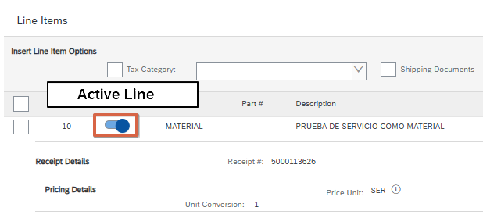
Select the lines you want to include and check that the quantity is correct.
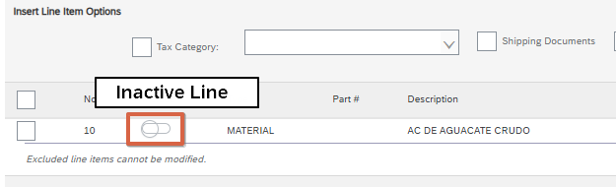
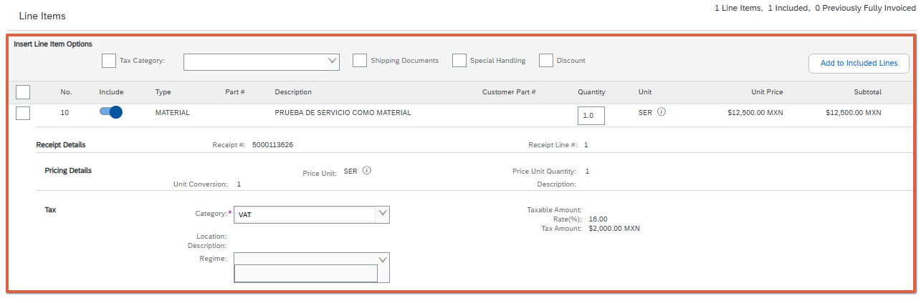

- Check that all the requested information has been completed and then click on "Next"
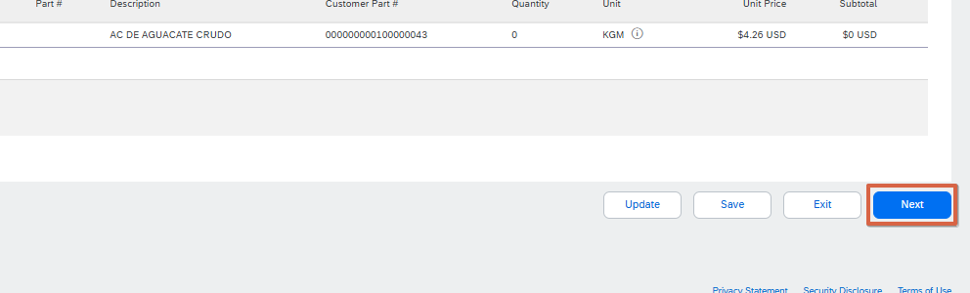

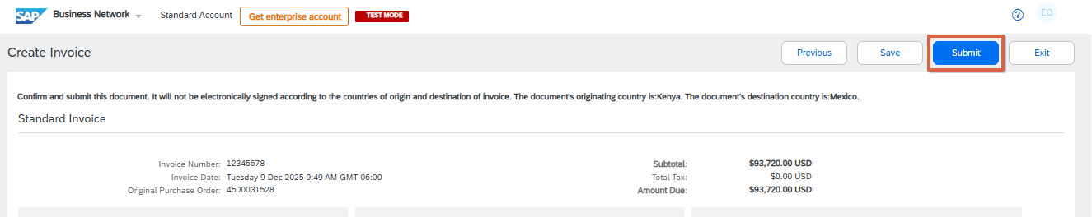
- Validate that all the information is correct and click on "Submit".

- Validate that the invoice was sent successfully. To do this, you must check that the status of the purchase order has changed to "Invoiced" or "Partially invoiced", depending on the case.
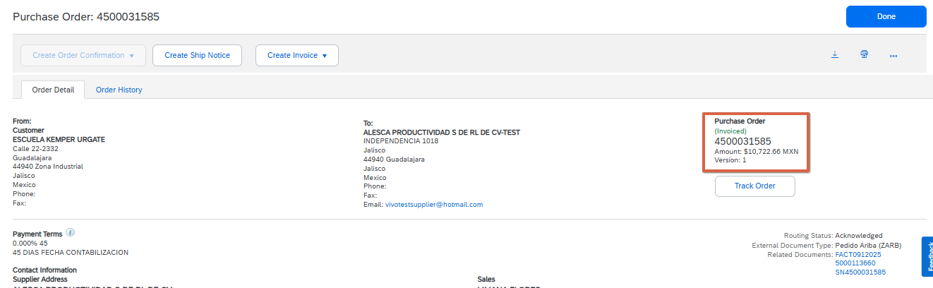

Validate Invoice Rejection
To check if the invoice was rejected, the following must be done:
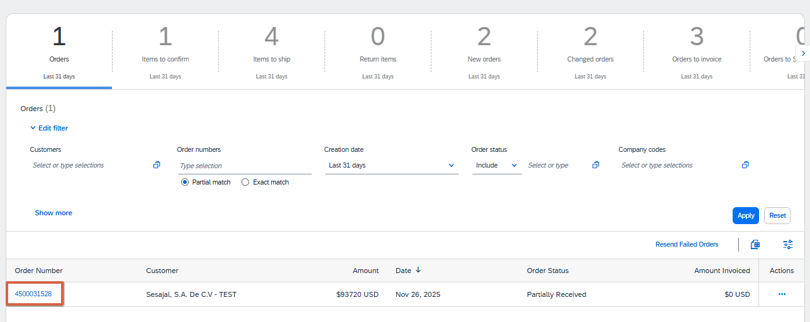
- Find and enter the purchase order where the invoice was sent.

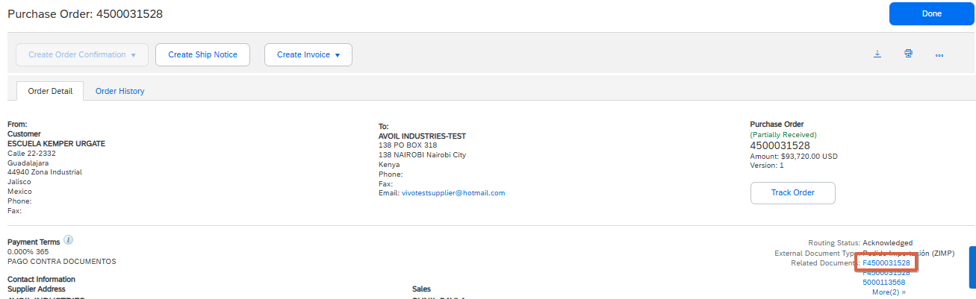
- Within the purchase order, you must look for the related documents section and enter the invoice sent.

- In case the invoice has been rejected, a light blue box will appear in the details tab indicating the reason for rejection. This can also be validated from the history tab.

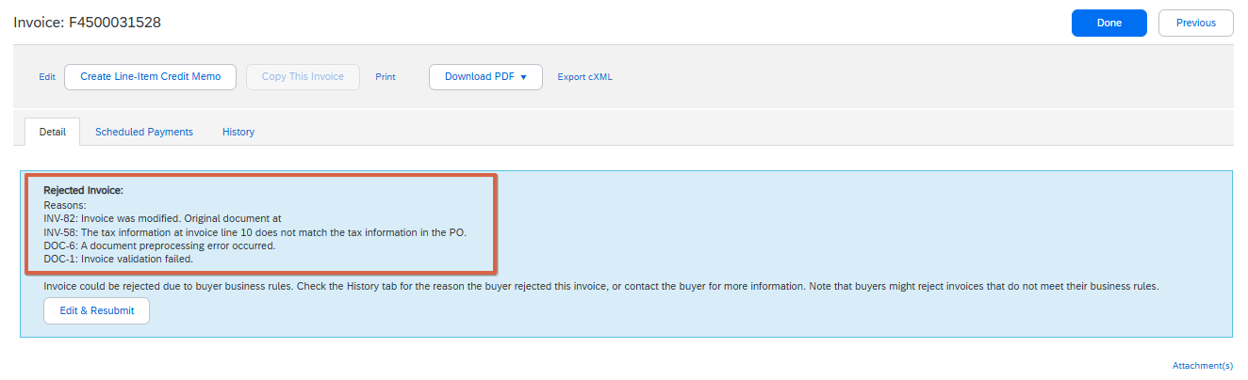

- After reviewing the reason for rejection, click on "Edit and resubmit". This with the aim of
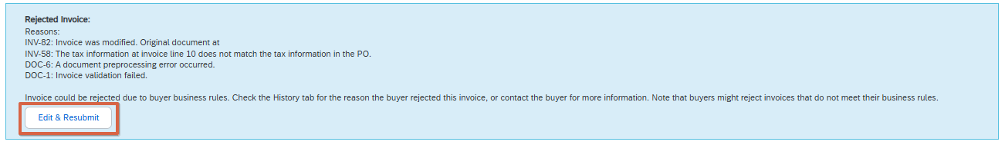
that the invoice should not be created from scratch.

- Make required modifications.
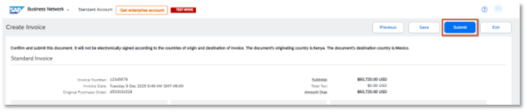
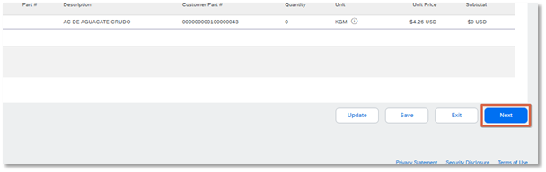
- Click on "Next" and then on "Submit".

Validate Invoice Status
Once you have sent an invoice, you can view the status it is in.
Note: Log in to your SAP Business Network account, by accessing from the following link: Ariba Network for Suppliers
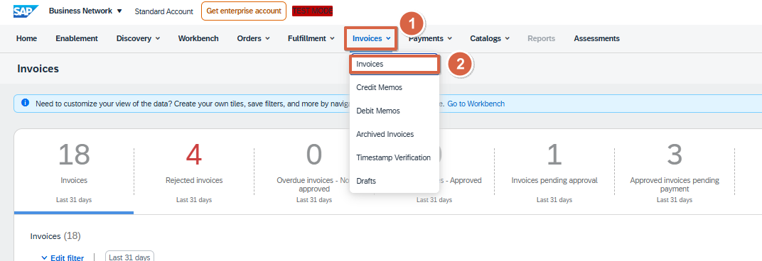
- Search and select the invoice to be validated.

- Once inside the invoices we can locate the one we are looking for in two ways.
  - Invoice number
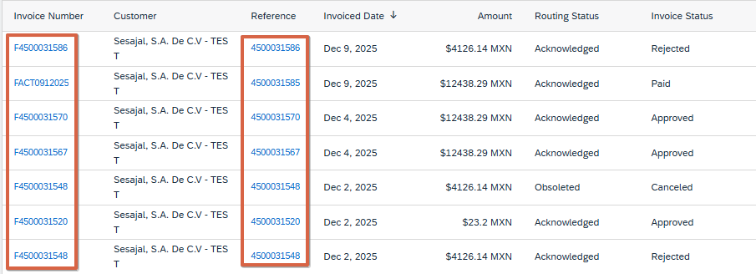
  - Purchase Order Number (Reference)

- After locating our invoice we can validate what state it is in, for this we have 5 possible options:
- Sent: The invoice has been delivered to the buyer.
- Approved: The bill was reviewed and approved (Not yet paid).
- Rejected: The invoice was reviewed and rejected (Can be edited and resubmitted).
- Cancelled: The invoice was reviewed and cancelled (This invoice is no longer valid, a new one needs to be made).
- Paid: The invoice was reviewed and paid.

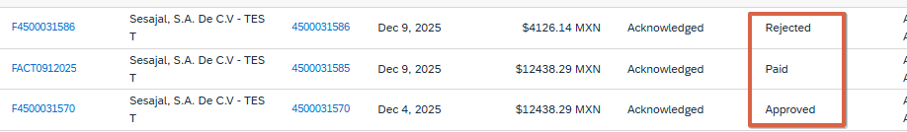

Invoice Information

- Once the invoice is located, you can access to view its information by clicking on the invoice number, where you can view the invoice number, the drop-down bar that includes:
  - Details: All the information regarding the invoice.
  - Scheduled Payments: If you have payments for upcoming dates, you can view them here.
  - History: you can view the process through which the invoice has passed.

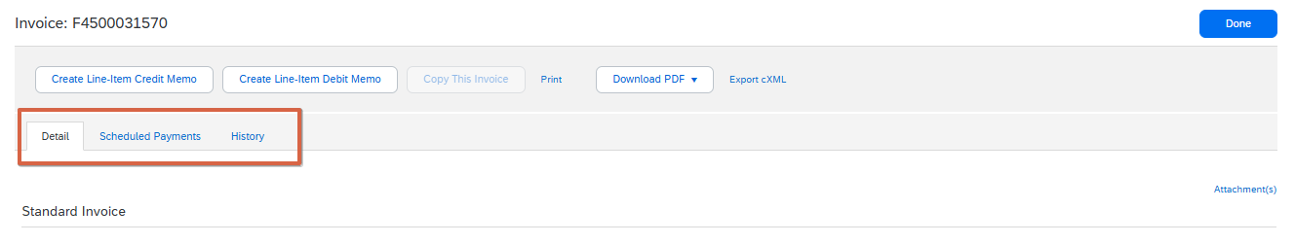

Invoice details

- Selecting the "Details" option is usually the default view. Here you will be able to see all the information of the invoice such as: status, payment total, payment method, see the image below.
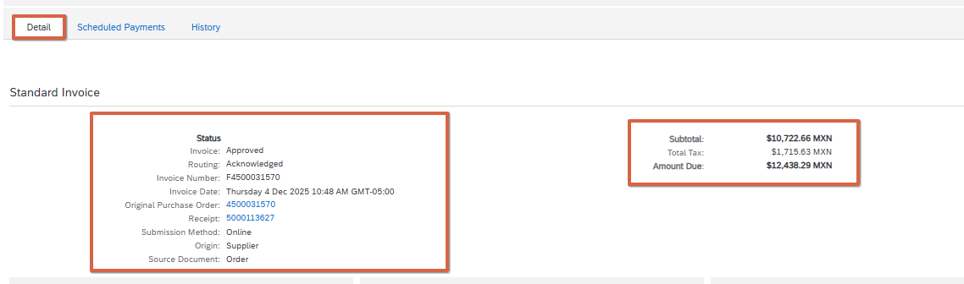

- In addition to the above, you will also be able to view the information of shipment, detail of the invoice, detail of taxes and Attachments. See images below.

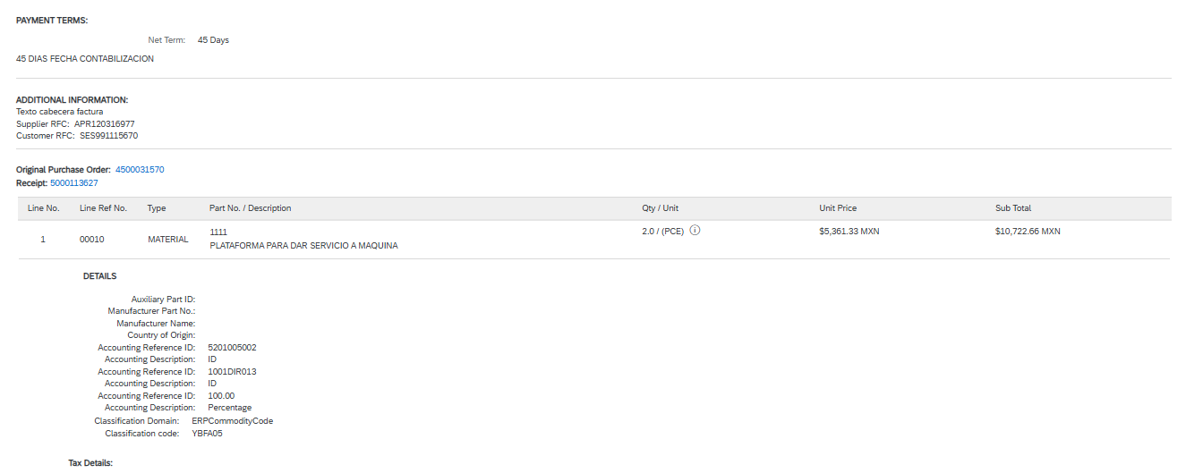

Scheduled Payments

- Select the "scheduled payments" option
If you have any payment scheduled on this invoice, you could see them in this tab

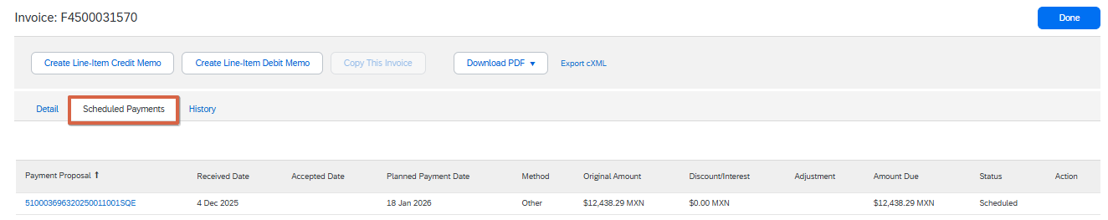

Note: If the status of your payment schedule is marked as 'on hold,' you must contact your buyer to inquire about the reason for the hold.

Historical
- Select the "Historical" option
Here you can see the process through which the invoice has passed. You can display the columns of:
  - State: The state in which it is located
  - Comments: If someone added a comment
  - Modified by: The person who made the modification
  - Date and Time: The date and time the change or update was made

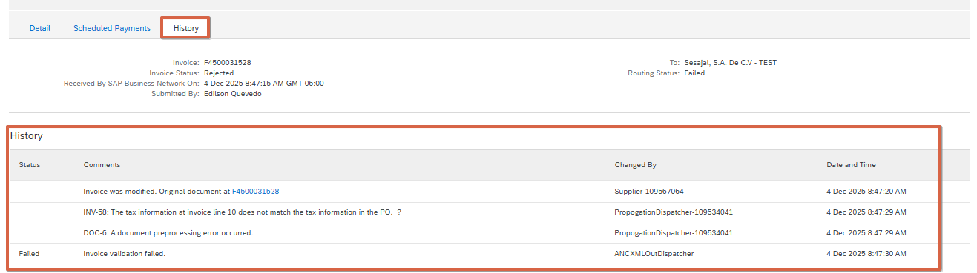

Payment Notification
- To view your payments made, go to the top of the home screen, select Payments, and then Remittances.
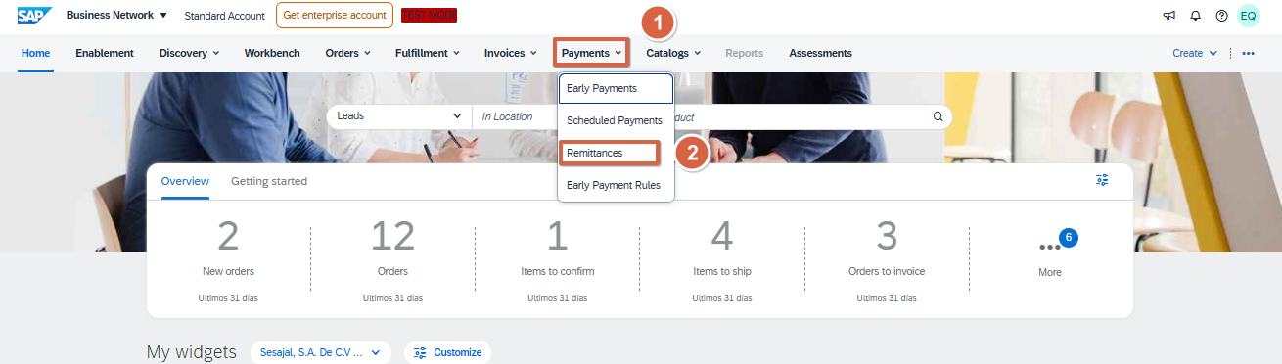

Remittances received
- On the payments page, you can view the payments received according to the filter you have applied and the total monetary amount received in the filtered period.
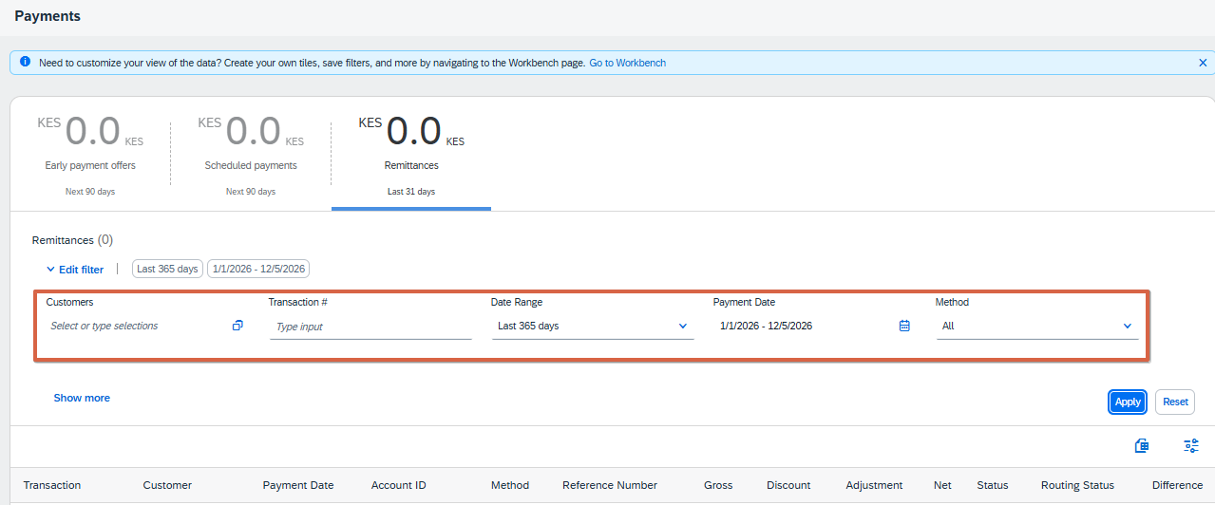

- After applying the filters, you will be able to view the remittances that correspond to that filter, locate the payment associated with the reference number that is the purchase order number to which the payment was made, and click on the transaction number to see the details.
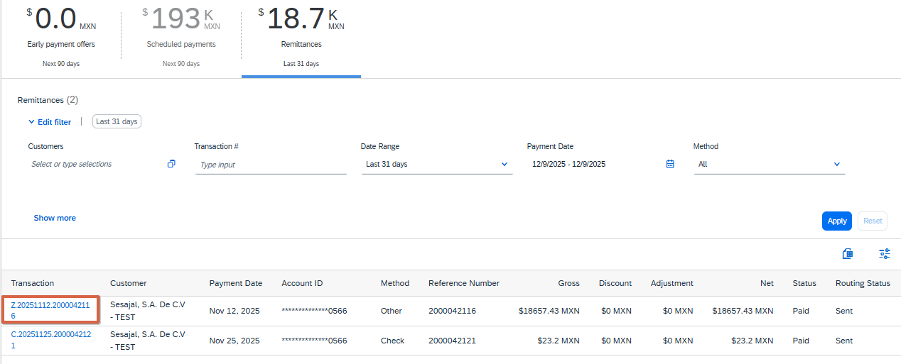

- Within the remittance you will be able to view the related data:
  - Remittance Notice Identification Number
  - Payment status
  - Gross Amount
  - Withholdings or discounts applied
  - Total amount paid
  - Payment settlement date
  - Payment Method
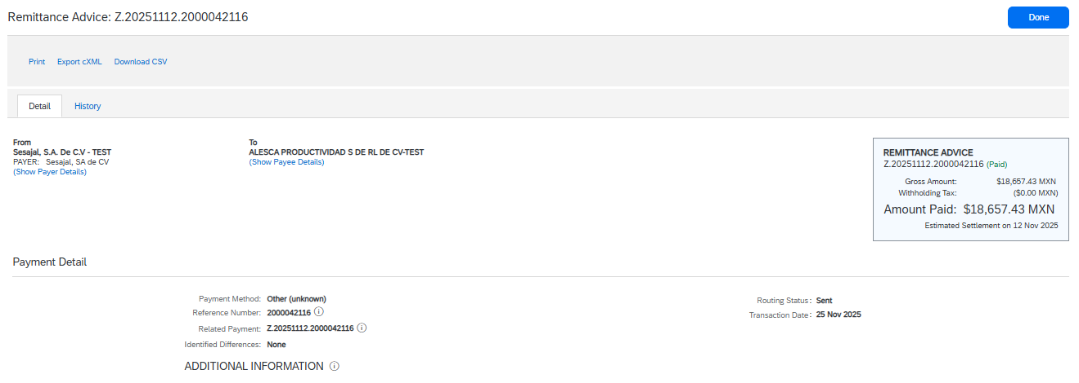
- In addition to the above, you can also view the invoices paid in this transaction, since a purchase order can have several invoices.

