

User Administration Manual
SAP Ariba Network



Dear User,

In order to support you in the development of activities within the SAP Ariba Network system, this guide describes the process required to manage your Ariba account.

We hope you find this manual useful,

Contents
Profile Information 3
Edit Profile 3
Edit Company Profile 4
Link user IDs 5
Forgot your username? 7
Forgot your password? 8
Recommendations 10

Profile Information

Edit Profile
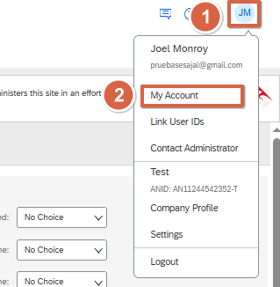
- In the upper right corner, you will be able to display the following panel of options. To make changes to the profile, you must click on the name, and select the "My Account" option.
You will be redirected to a tab where you can make the following changes to your Ariba profile:
  - Account information: username, email, name, among other options
  - Preferences: Preferred language, preferred time zone, or default currency
  - Contact Information: Phone Number, Address, Zip Code
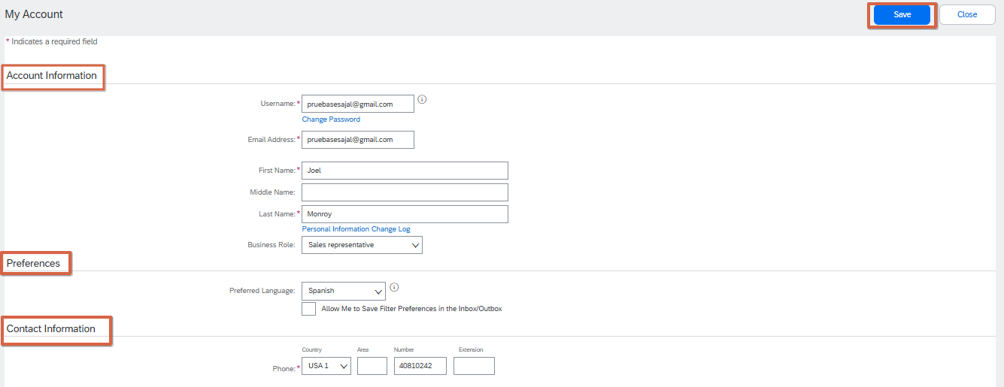
- Once the changes are complete, select "Save"

Edit Company Profile
Note: This information is NOT required by your customer, you can optionally fill it out to enhance your profile on the SAP Ariba platform and interact publicly with other customers.
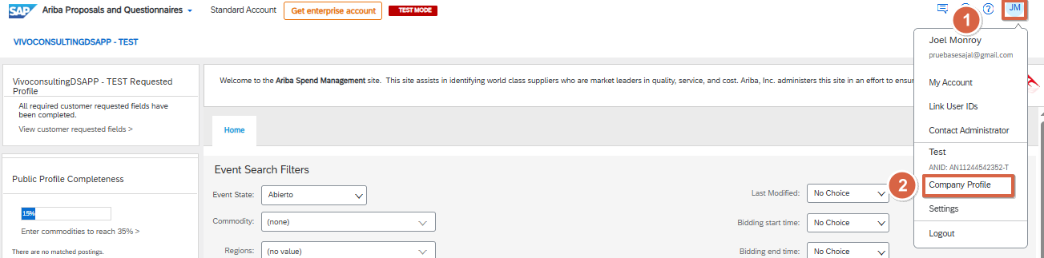
- In the upper right corner you will see the following panel of options. To make changes to the company profile, you will need to select your initials and select the "Company profile" option.

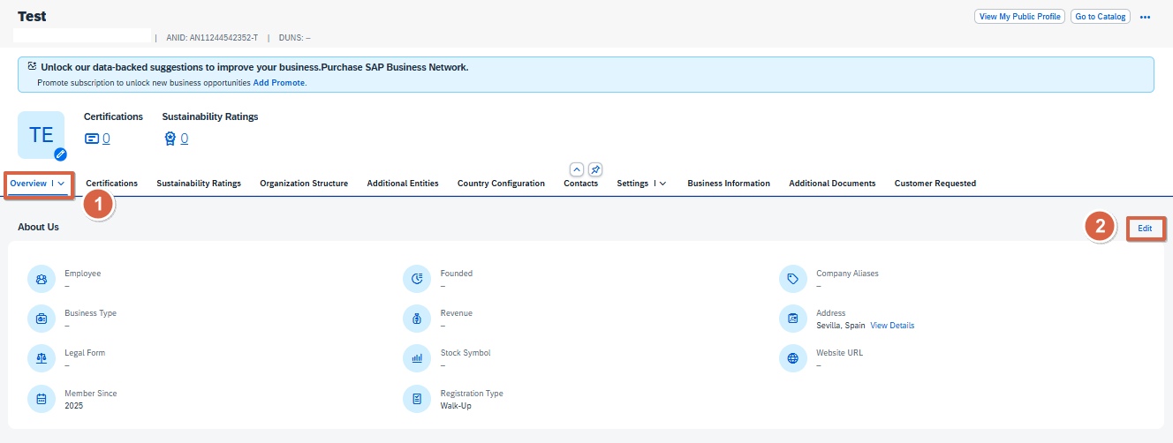
- In this option, you can make changes or add information about your company.

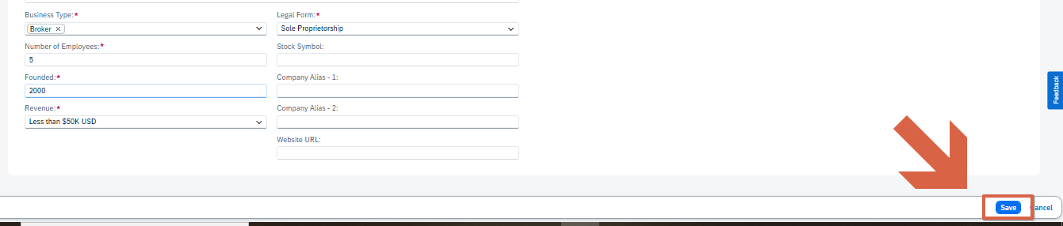
- When the changes are finished, press the "Save" button.

Link user IDs
This feature allows you to manage the different accounts within your company and thus be able to perform the following functions:
- Log in to entered accounts with a single username and password
- Quickly switch from one account to another

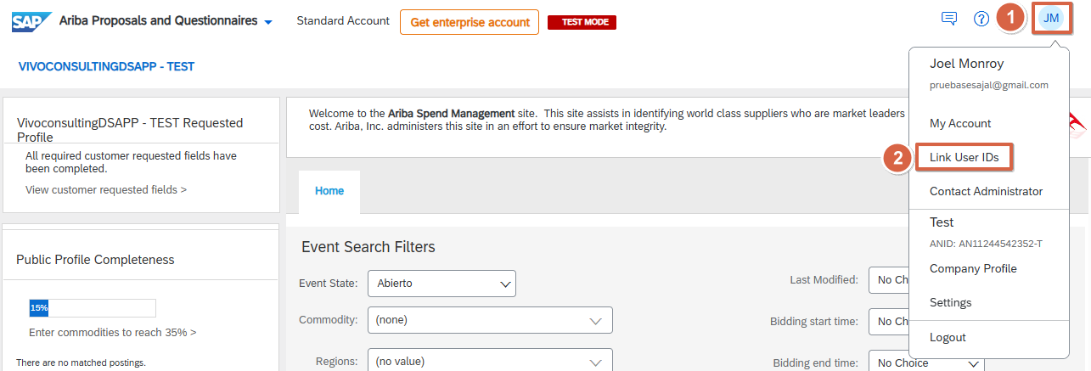
- Select your profile initials and click on "Link User IDs"

- Once this option is selected, the page will appear where the process of linking user IDs can be carried out. The page shows two options:
- Approval required: in the case of not knowing the password, you must enter the name of the user to be linked, select "Send link request" and they will receive an approval via email to link the account.
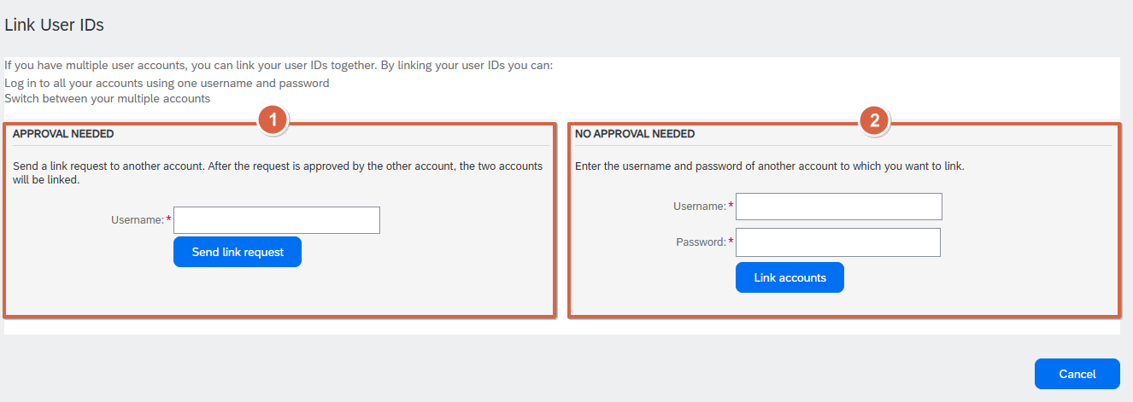
- Approval not necessary: in case of knowing the password of the additional user, you will be able to link automatically, entering the username and password of the user and select "Link account".
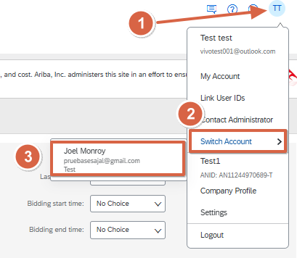
- The result is navigation between accounts that you can do by selecting your profile initials > switch account.

Forgot your username?

- Enter the system through the address (URL) of the site.
http://supplier.ariba.com
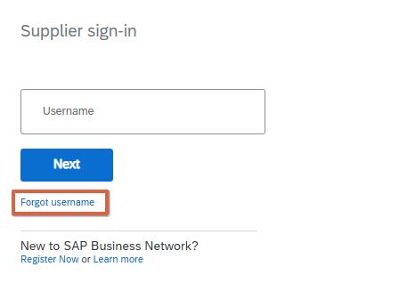
- Under the login boxes, you will find the option "Forgot username", and you will need to click on the phrase.

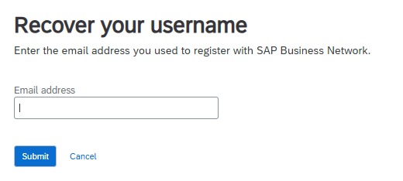
- The system will display a new window, where you will need to enter your email address registered in Ariba.

- At the end, press the "Send" button.
- You will receive an email with a link indicating the username

Note: It is recommended that before entering the link sent via email, you have closed the Ariba pages that are open in the browser.

Forgot your password?
- Enter the system through the address (URL) of the site.
http://supplier.ariba.com
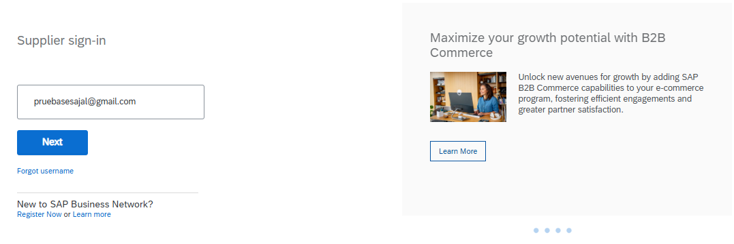
1.1 You will need to enter your username.

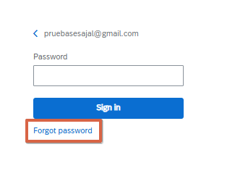
- Under the login boxes, you will find the option "You have forgotten the username or password", and you will have to click on the phrase "the password".

- The system will open a new window, where you will need to enter your email address registered in Ariba. At the end, press the "Send" button.

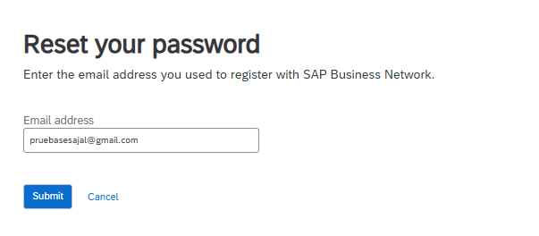
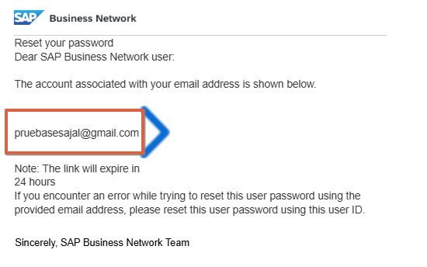
- You will receive an email with a link so that you can reset your password. Note: the link is located inside the username.

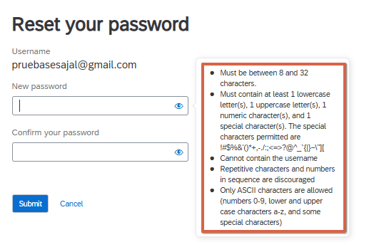
- Enter the link and enter a new password which must meet all the requirements, as well as its confirmation. At the end, press the "Send" button.

Recommendations

- To optimize the use of SAP Ariba, the most supported web browser is Microsoft Edge in its current version.
- Write down your username and password in a safe and easily accessible place. You can rely on the password manager of the Microsoft Edge or Google Chrome browser.
- Verify that Ariba system notifications are not directed to the "Junk" or "Spam" folder. If so, you must validate that you do not have the Ariba administrator blocked as the sender.



